Overview:
Title: Try, catch, throw
Format: PC VR (Rift platform)
Genre: First person shooter
Theme/Type: 1st person
Target Audience: PG-13
Software used: Unity, Maya, Cinema 4d and photoshop.
Game premise: The player catches, cooks and throws small grenades from a tower at enemies below to protect themselves and the tower.

Description:
Title: The title perfectly describes the game and is programming related, which might become the theme of the game.
Sub goal: To collect special items (power ups) from dead enemies and catch harmful objects thrown at the player from the enemies below.
Outline of game concept: The player stands on top of a tower and throw grenades at enemies below. Enemies would spawn randomly and try to move close to the tower to attack it. Killing enemies would drop grenades and other useful items. Enemies would throw things at the player to attack the player and the tower.
User Control: Users use their tracked motion controllers to throw and catch things. Users can “force pull” far-away objects close to them by doing a special gesture. Users can also cook grenades or do other special things by pressing buttons on their controllers.
Unique aspects: The game is unique in that there isn’t currently a game where grenades and throwables are the main weapon.
How to win: You win by staying alive against a certain number of enemies.

Accumulators:
Points: your score. You get points for killing enemies/picking up special items.
Health of player, heath of tower: you have to maintain and keep an eye on both.
Variance: Enemies are spawned semi randomly and drop items semi randomly. The amount/quality of enemies and dropped items will be tuned to slowly increase the difficulty of the game overtime.
Levels: Levels would have different maps, creating different blind spots for the player. Levels would also have level specific mechanics and enemies.
How will your game be fun: “Forcing pulling” things in VR itself is a fun and rewarding mechanic, especially when you grab things moving in midair. Cooking grenades in VR is also a lot more entertaining than in flat screen games as players will be more self-aware and fear more from the explosive they are holding in their hands. This creates a unique thrill that’s hard for flatscreen games and other VR mechanic to mimic.

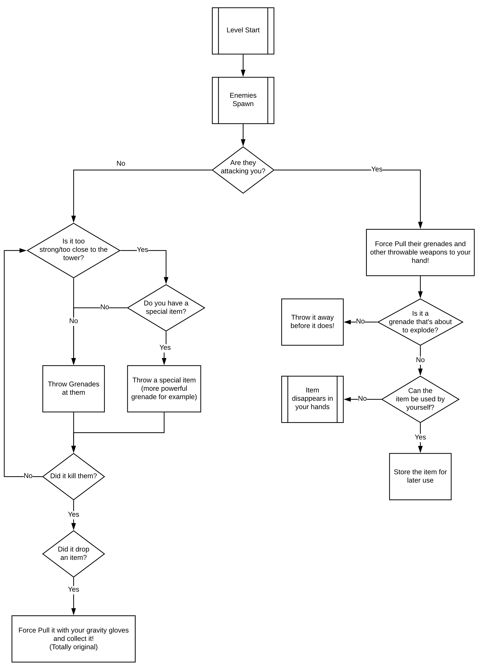
Flowchart:

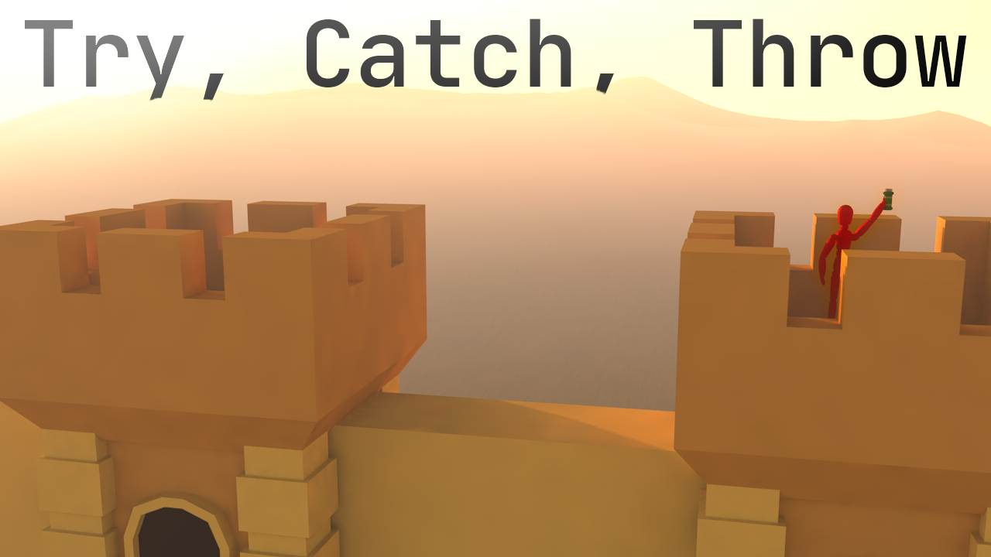
Cover Art/Concept Art

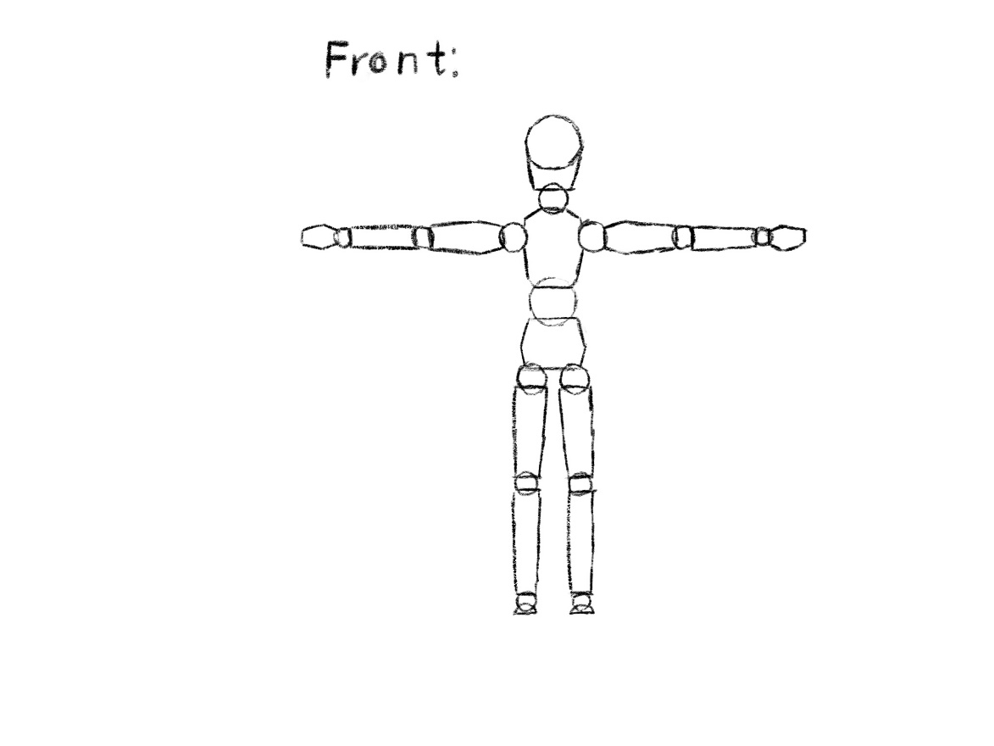
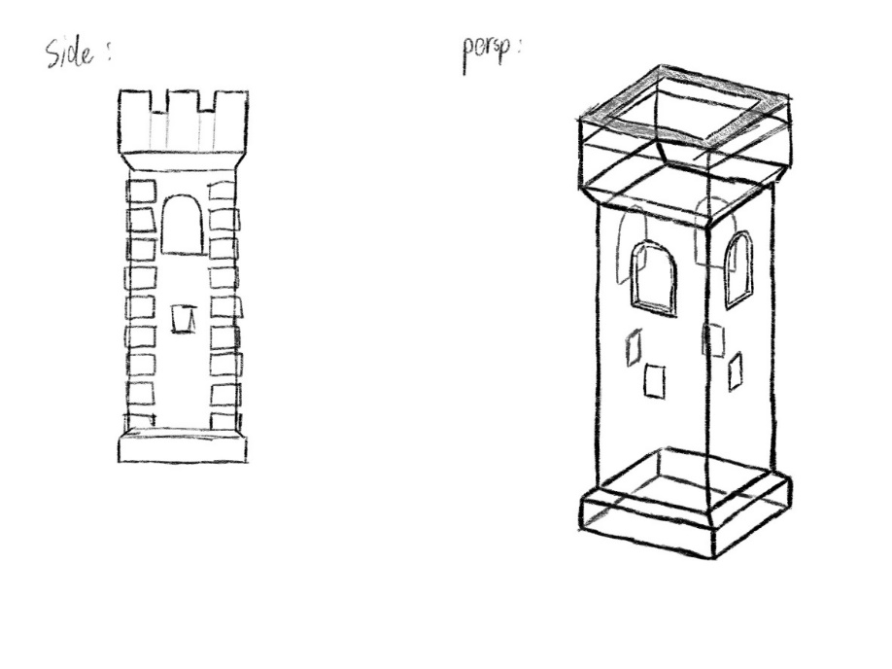
Character/Object sketches:

Unused idea

Proposal Criteria:
Title: Distance, Format: PC VR game, Genre: Stealth, Theme/Type: 1st person, Target Audience: PG13, Software used: Unity and Maya, Game Premise or Concept Statement: You attempts to cure people from a contagious disease called covid-91 while avoiding it yourself by staying 2 meters away from people and by finding randomly spawned masks.

Description:
Title: The title is a commonly used word, making the name easier to remember. It is also very vague and doesn’t tell much about the game itself, evoking curiosity in potential players.

Game premise:
You attempt to cure people from a contagious disease called covid-91 while avoiding it yourself by staying 2 meters away from people and by finding randomly spawned masks.

Sub goals:
You find randomly spawned gloves. With the gloves, you can simply snap your fingers to cure half plus a fixed number of the people and make them immune to the disease.

Outline of game concept:
You start in a building. Occasionally, a new covid-91 patient will appear and wonder around the building semi-randomly. You must stay 2 meters (The distance might change to improve gameplay) away from a covid-91 patient or be wearing a mask to avoid getting the disease yourself.
Masks are randomly spawned in the map occasionally and will get rarer as time goes on. Masks can protect you for a fixed amount of time when you are in close contact with a patient.
Gloves are also spawned randomly in the map occasionally, and they will usually be placed on the far side of the map, requiring the player to go through the entire building to reach. By snapping your fingers while wearing a glove, you can cure half plus a fixed amount of people from the disease. Cured patients will gain immunity and will not contract the disease again.

User control:
A few continuous locomotion options will be available to the player, including but not limited to: Joystick in the direction of the head, joystick in the direction of the controller, or move forward in the direction of the controller.
Users use their masks by putting it on their face.
Users snap their fingers while wearing the gloves by pressing a button.
Users can store and retrieve masks in their wrist pocket.
There is no pause option, as there is no way to stop the user from moving their bodies in paused, which will make the gameplay easier.
The main menu would consists of large buttons which can be used by pointing and clicking with the controller.

Unique aspects:
Everything! I’ve never heard or seen any game like this.

How to win:
By curing everyone using the gloves

Accumulators:
You have a “infection meter” which goes up when you are within 2 meters from a patient and not wearing a mask. It goes up faster the closer you are to the patient.

Variance:
The patients, masks and gloves spawn in semi-randomly based on time. Their position is also semi-random.

Levels:
Different levels would have a different map in increasing difficulty. (for example, a long narrow hallway would make it harder to avoid the patients) Some maps might also have map specific mechanics, for example, a map could have a teleporter that connects 2 points in the house.

How will your game be so much fun or successful?
The fun would come from moving your head and body to avoid being too close to a patient.

